Press release, 25 November 2009
Fat lady disappeared (assumed drowned) by the little Mermaid
The 3 metres high sculpture ’Survival of the Fattest’ has apparently disappeared, and it is like sunk into Øresund. The artist goes to Copenhagen tomorrow morning with a big crane. Together with some employees he will look for the big sculpture under the water.
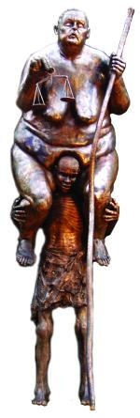
The sculptor behind the sculpture Jens Galschiot has just sent out a press release about the set up of the high sculpture ‘Survival of the Fattest’ next to the little Mermaid. The sculpture, which was set up a week ago, represents an overweighed Justitia goddess sitting on the back of an African man.
“There was great consternation on the workshop, when the first Copenhageners called at 2 p.m. and told us that the 800 kilo big bronze-sculpture had disappeared.
I have received some photos of the place where the sculpture should stand. At first you can only see the bright water where it stood before. But some small buoys indicate that she possibly is lying under the water. The sculpture stood up to the hurricane-like storm last Wednesday, so maybe someone has had their boat or something else out and drawn down the sculpture. It is hard to say. I will not know before tomorrow, when we will have our people there.
I hope, she lies under the water and that she has not been damaged. We expect to find and raise it, so the Copenhageners and participants of the conference will have the pleasure of the artistic comment to the global warming and the double-standard of the Western World,” says Jens Galschiot.

Contact Jens Galschiøt, phone 6618 4058, mobile 4044 7058
Mail: aidoh@aidoh.dk, info: www.aidoh.dk

More information: info: SevenMeters.net
Photo: http://SevenMeters.net/links/6/ tel. 6170 3083 / 6618 4058

Professional documentary shoots of the Mermaid set up:
Niels Madsen, mobile: 40 215 415
nillermadsen@mail.tele.dk, www.osrtv.dk

